

**Families Newsletter December 2019**

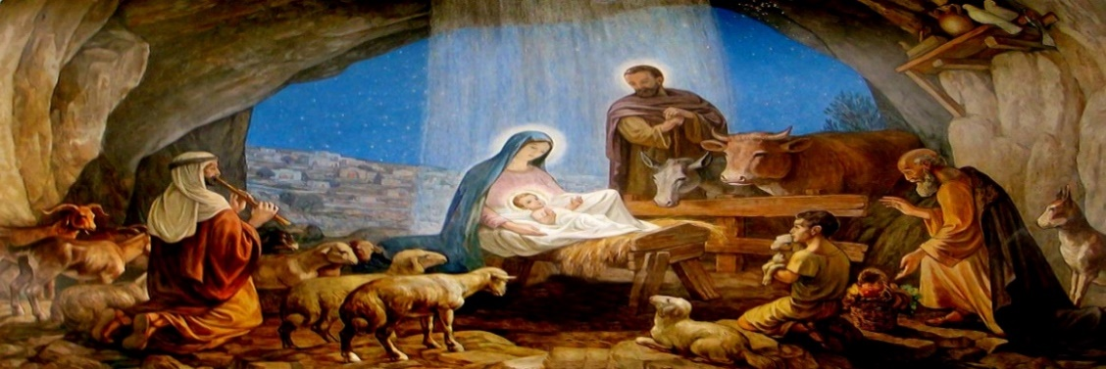

There’s lots going on in the Solihull Parish for families.

Everyone is welcome!

**Sunday Worship**

**St Alphege Church (B91 3RQ)**

You are welcome at the **9:15am** in the church building. Worship with a mix of traditional and contemporary music in our beautiful church. Space for all ages with dedicated activities for children.

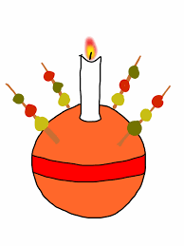**CHRISTINGLE ALL AGE EUCHARIST, Sunday 8th December**

At 9.15am on Sunday 8th December we will all worship together in the church building. Come along to this special celebration and make your own Christingle to take home.

**“The Junction”** meets at **9.15am** in the Oliver Bird Hall (OBH) – adjacent to the church building.

An informal service for young families offering tailored activities for children of all ages,

from babies to big kids. It’s lively and laid back!

On Sunday 15th December the Parish puppet team will be visiting the Junction to perform

Bethlehemian Rhapsody – Don’t miss it!!

On Sunday 22nd December it will be the Junction Nativity – Come along dressed as your favourite Nativity character!

**The Junction will be taking a break on 29th December but will return on 5th January when we’ll think about the visit of the wise men.**

You are welcome at the **11am**. A choral service with our excellent choirs. Time to reflect and wonder.

We have Choral Evensong at **6.30pm** - a traditional contemplative service enjoyed by Christians and people of no faith (there is also a short Choral Evensong service on Wednesdays at 6.30pm

which can give a peaceful half hour break in the middle of the week)

Christmas Services

St Alphege Church

**Sunday 1 December**

3pm Ecumenical Crib Blessing Service at Mell Square

6.30pm Advent Carol Service

**Sunday 8 December**

9.15 Christingle All Age Eucharist

**Sunday 15 December**

6.30pm Nine Lessons and Carols

**Saturday 21 December**

7pm Handel’s Messiah (Tickets: Adults £12, Children FREE)

**Christmas Eve**

3pm and 4.15pm Crib Services

11.30pm Midnight Mass

**Christmas Day**

8.00am Said Eucharist

9.15am Christmas Day All Age Eucharist

11am Christmas Day Choral Eucharist

**Sunday 29 December**

10.30am Sung Eucharist

**New Year’s Day**

11.00am New Year’s Day Parish Eucharist

**Sunday 5 January**

6.30pm Epiphany Carol Service



Christmas Services

St Michael’s Church

**Sunday 8 December**

10.30am All Age Nativity Service at Sharman’s Cross Junior School

**Sunday 15 December**

4.30pm Carol Service at Sharman’s Cross Junior School

**Sunday 22 December**

4.30pm The Longest Night Service at St Michaels

**Christmas Eve**

3pm Crib Service at St Michaels Chapel

11.30pm Christmas Eve Eucharist at St Michaels Chapel

**Christmas Day**

10.30am Christmas All Age Eucharist at Sharman’s Cross Junior School

St Helen’s Church

**Sunday 15 December**

4pm Christmas Jigsaw Service with Puppets

**Sunday 22 December**

6.30pm Carol Service

**Christmas Eve**

4pm Crib Service

**Christmas Day**

8am Christmas Day Eucharist

10am Christmas Day All Age Eucharist

**St Michael’s Church (B91 1BS)**

You are welcome to come along to St Michael’s at **10.30am** every Sunday at Sharman's Cross Junior

School (B91 1PH). We meet in the school hall where we create a warm, welcoming space for all ages to

worship, with a creche for little ones and activities for children of all ages.

**St Helen’s Church (B91 2DA)**

You are welcome to St Helen’s at **10am** on the 1st, 2nd, 4th and 5th Sundays. Worship in a modern space

with a strong community feel and a range of traditional and contemporary music.

Tailored groups for children. **Jigsaw** meets at 4pm on the 3rd Sunday, monthly – more details below.

**Weekly Activities**

***OASIS*** *Tuesdays* in term time 9.15 – 10.15am in the Oliver Bird Hall.

A warm and welcoming space for parents to meet each week for friendship and support, share a

cuppa and talk about love, life, family and faith. Toys are provided for the children to play with,

while you enjoy a cup of tea of coffee, posh biscuits and time to chat with other parents.

***Prams to Preschool* - Praise and Play:** Every *Friday* from 9.30am onwardsin the Oliver Bird Hall.

Fun and fellowship for all. Come along and chat, eat biscuits,

sing action songs and explore a bible story.

**St. Alphege Choirs:** We are fortunate to have choirsfor boys and girls from Year 3 upwards.

They rehearse weekly and sing at Sunday morning services and Choral Evensong. Visit [www.stalphegemusic.org.uk](http://www.stalphegemusic.org.uk) to find out more.

**Parish Youth:** There are lots of exciting things going on in the Parish for

young people from Year 6 upwards run by the **Parish Youth** team.

*Wednesdays* (alternate weeks) 7pm – 8pm *Fridays* 5pm – 6pm and 6pm – 7.30pm



**Youth Christmas Party,** St Helens Saturday 14th December, 7.30-10.30pm. £17.50 to include food, disco, entertainment. RSVP The Youth Team or Joes Minall 07746 708860

**Women’s Theology groups:** All women are welcome to join us in discussing the Bible and how it

applies to our daily lives. We meet twice each month with three different groups

(Thursday 2pm, Thursday 7.30pm, Friday 10am) to choose from.

For more information and to sign up, please contact Charlotte Gibson:

[chachagibson@gmail.com](mailto:chachagibson@gmail.com) 0121 709 0668.

**Other Activities in December & beyond**

**Messy Church -** Suitable for families of all ages with lots of creative activities and a hot child-friendly meal to finish.

**Save the date, January 10th, 2020 Epiphany-The Wise Men followed the Star**

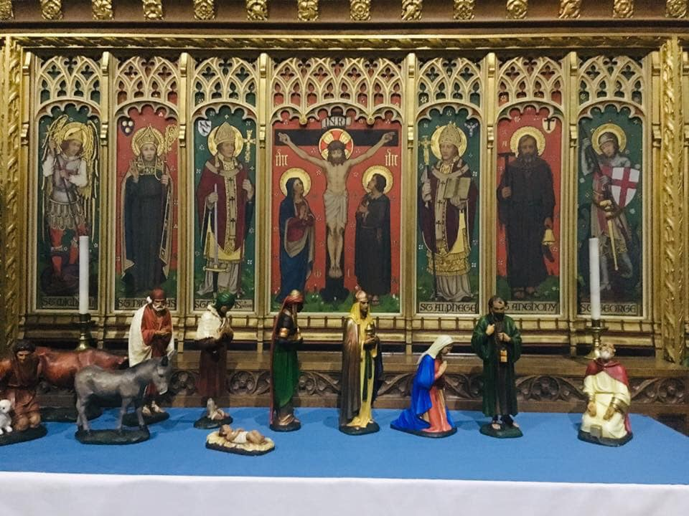

4-6pm at St Helen’s Church, St Helen's Road (off Buryfield Road) B91 2DA. £2 per person, £7 per family. Send an email to Linda [l.hicks@solihullparish.org.uk](mailto:l.hicks@solihullparish.org.uk) if you can make it so we can make sure we have enough food!

**Jigsaw:** A time to get together with others to explore a Bible story in lots of different ways, to sing and pray to God and to have tea together. It’s for everyone and we hope it will be for you!

Join us for the next session at St Helen’s Church, St Helen’s Road (off Buryfield Road), Solihull, B91 2DA on **Sunday 15th December with puppets and then Sunday 19th January 4pm.**

**St. Alphege Pre-school Groups (held in the Oliver Bird Hall)**



**Pre-School Christmas Fair**

**Sunday 15th December 2.00pm-4.00pm**

Tombola-raffle-music-food-drink-crafts-stalls-games

**£5 entry for children, includes a visit to Santa’s Grotto**

**Adults £1 on entrance**

Contact Stacey 07813 172469 chair@stalphege-preschool.org.uk

**Little Treasures:** *Wednesdays* in term time 1pm – 2.30pm.

Drop-in ‘play and stay’ session for children aged 0 – 4.  Early Help resources around children’s milestones and development are on display and available to take home.

£4.50 per family includes refreshments.

**Little Movers:** *Mondays* in term time 9.30am – 11am.  Activities to offer children the opportunity to further develop social, language and physical skills in the academic year they will turn two years old.  Drop-in ‘play and stay’ session – no need to book.   £4.50 per child (£1 additional siblings, maximum charge £6.00 per family) includes refreshments.

**St. Alphege Pre-school:** Ofsted ‘Outstanding’ for second consecutive inspection.  Early years education for children in the academic year they will turn three years old.  Monday to Friday term time 9.10am – 12.10pm.  Applications on website <http://www.stalphege-preschool.org.uk/>

or email request to [manager@stalphege-preschool.org.uk](mailto:manager@stalphege-preschool.org.uk)

**Christian Men Together – Regular events throughout the year**

For more information and to book please contact:

Andrew Williams – arwilliams399@gmail.com

 The youngest section in Scouts and open to both Boys and Girls aged 6 – 8. We take part in lots of activities which helps us make new friends, learn new skills, explore our world, play games but most of all have fun! Beavers meet on a Monday or Wednesday evening.

To find out how to get your child onto the waiting list please email:- [waitinglist@6thSolihullScouts.org.uk](mailto:waitinglist@6thSolihullScouts.org.uk)  Or to find out more information call Patrick Taylor (Group Scout Leader) 07711 062127

**Family Information Form**

The Parish are checking details of families who attend church services and activities in the Parish to ensure we have the correct information. Many families have now completed forms but if you haven’t yet, please ask for one from the leader of the children’s activity you attend or at the Parish Office.

**Safeguarding**

The Parish take safeguarding of everybody seriously but in particular children and vulnerable adults. We are all vulnerable adults at some time in our lives. It is everybody’s responsibility so if you have a concern or allegation, including those in the past, regarding safeguarding in the church please raise it.

You can contact Viv Dobson, the Parish Safeguarding Co-ordinator, on 07960 783636 or a member of the clergy.

Contact details are on noticeboards in each church as is a copy of the safeguarding policy. Information is also available on the website [www.solihullparish.org.uk](http://www.solihullparish.org.uk).

***May we take this opportunity to wish you and your families a very Happy Christmas and thank-you so much for your support throughout 2019***