The Friends of St Alphege Music

Annual Report

1 September 2022 to 31 August 2023

Prepared for our AGM – 22 October 2023
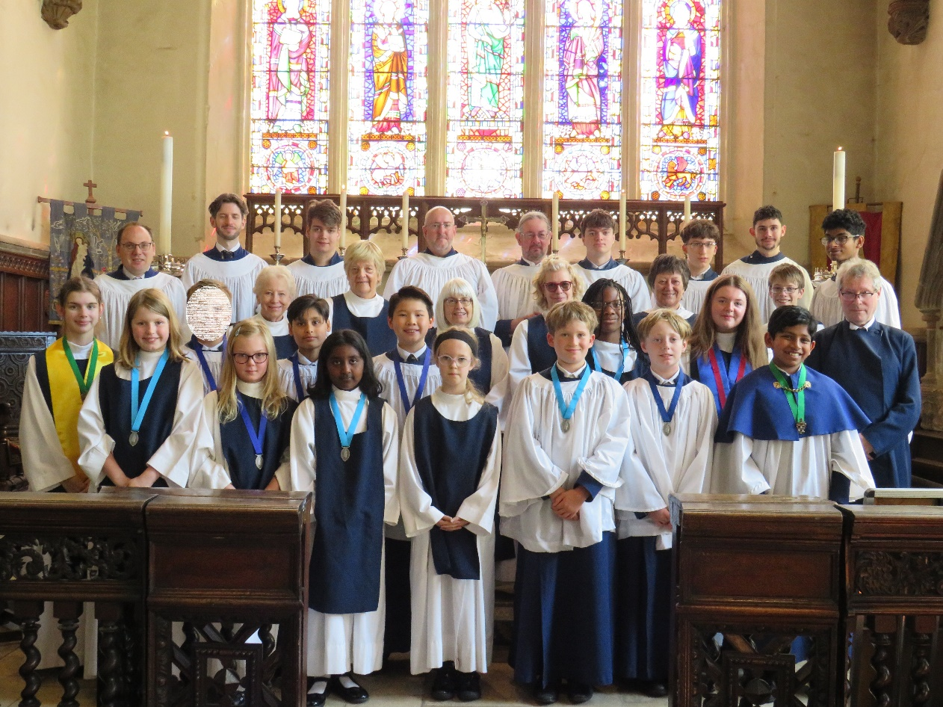

The Friends of St Alphege Music is a charity registered in England and Wales, number 511237.

Report from the Chairman – Nick Cahm

My annual look-back over the year to prepare for the AGM is a good opportunity to pause and reflect on how much has been achieved by FoSAM during the period as well as appreciating the important contribution made by all those involved with FoSAM in whatever capacity. As always it is a team effort, whether that’s attending our big events, helping with cakes for the recitals or being part of the organising committee, to name but a few. Every contribution, whether financial giving or the giving of time, is appreciated and goes towards helping to achieve FoSAM’s aims. The last quarter of 2022 and the first three quarters of 2023 have proved to be successful for everyone involved with the music of St Alphege and FoSAM has helped to make that happen.

A highlight, which may go under the radar for some, has undoubtedly been the weekly lunchtime recitals. These take a great deal of work to organise, with coordination of the players (sometimes having to find replacements at the very last moment), creating rotas, being there to welcome people and to guide any late-comers, making the delicious cakes, serving the cakes and facilitating the hot drinks. It’s a great team effort. I’ve been fortunate that, due to a change of jobs, I am often able to be at the Wednesday lunchtime recitals (albeit, I can only stay until 1:30) and have marvelled at the high quality of the music week in, week out. These are culturally-important events for Solihull as well as being a steady source of income for FoSAM. Please continue to support the recital series and let’s hope that we can attract new audience members as word spreads about the great music (as well as the delicious cakes!).

Whilst the regular recitals are vital to support the work of FoSAM, it is the major events that steal the headlines, and probably rightly so. There are many months of planning that go into our very successful Beer Festival and the Gin & Jazz Festival. I get a huge sense of achievement when these events are pulled off successfully and I am sure that the team of helpers and organisers find these events a pleasure to be involved with too.

The Beer Festival was held once again in November 2022 after the hiatus caused by the Covid pandemic. I covered this festival in last year’s report, as the AGM fell just after the Beer Festival weekend. However, it is worth reflecting on how it was a very successful event, which helped to fund much of the work of FoSAM through the year. As mentioned in that report, we struggled for volunteers for the event so it was a major challenge, especially since most people involved were almost complete novices when it comes to beer and running a beer festival! However, our team spirit helped us through and we had a pleasing outcome. The 2023 Beer Festival is rapidly approaching and I am optimistic that we will build on the success of 2022 and it will be even more successful. I must mention the great work that has already been undertaken by committee member James Mawson who has selflessly been visiting similar beer festivals both near and far, gathering ideas for our festival, speaking with organisers, identifying potential sponsors, and (occasionally?) sampling the beers. His expertise will be pivotal in making this year’s beer festival the best ever. I’d urge anyone to volunteer to help out in any capacity. Those requests for help will be sent out shortly.

The other major fundraising event was the Gin & Jazz Festival held on 3rd June. We were extremely fortunate with the weather (it was probably better than almost any day in August) and had very good attendance. We had a superb selection of gins and associated mixers as well as having a small selection of beer. We had a wide range of helpers, none working harder than the kitchen team, and top-quality musicians keeping the crowds entertained throughout the event. There was a great atmosphere throughout and despite overheads for this event being particularly high, we made a good return and made many new connections for FoSAM.
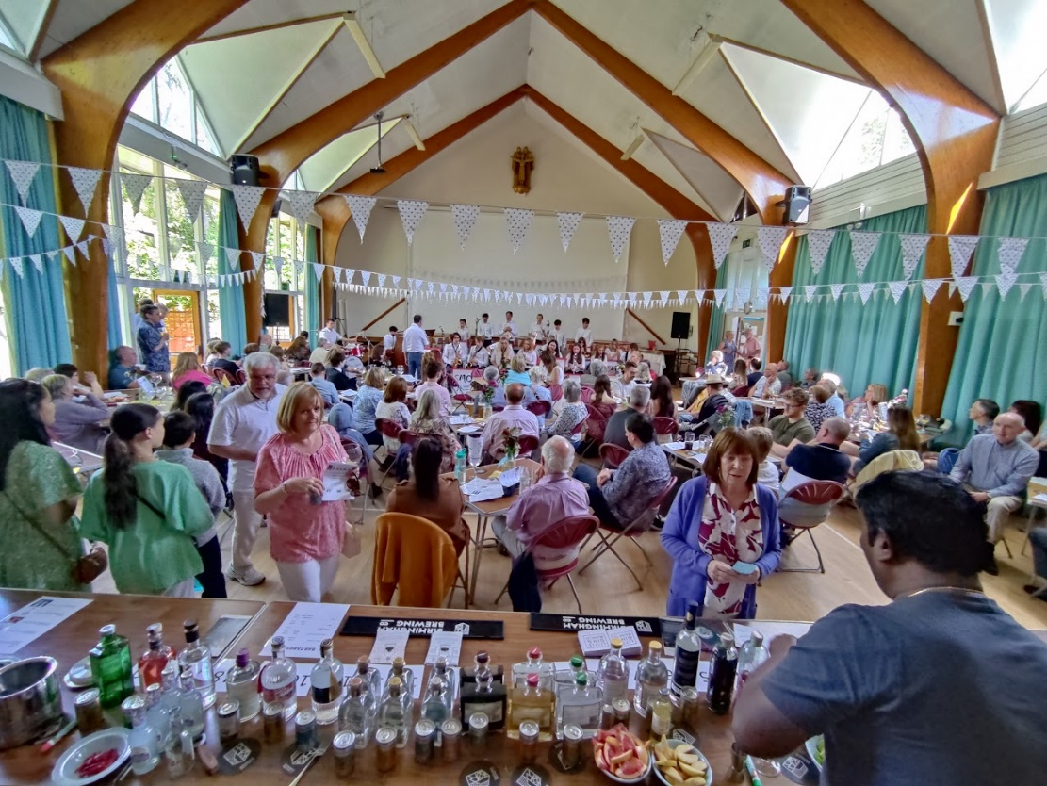

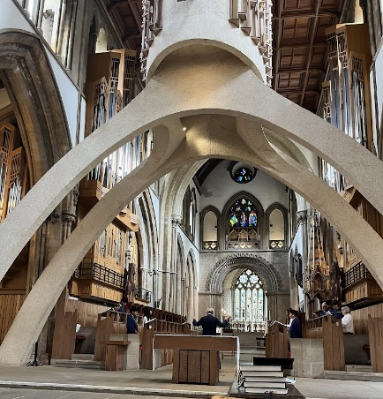
The other major event was one funded by FoSAM, which was the week’s residency at Llandaff Cathedral. Aside from the music, these residencies are a great experience for all attendees, giving the opportunity to strengthen friendships, develop musicianship and experience music making of the highest standard at world-class venues. We were made extremely welcome in Llandaff and I am sure everyone involved had a memorable week. Again, the small team of organisers excelled, ensuring that every eventuality was covered and creating an ideal environment for everyone to be able to contribute fully to the activities of the week.

I will leave most of the musical summary to Chris, but should highlight a few changes that have happened over the past year. Two Junior Organ Scholars have been appointed who, despite their young ages, have played during several services, often without the congregation knowing that it was a mid-teenager playing rather than one of the great team of organist talent that we call on to play at services. We have also had Ewan Murray in the role of Senior Organ Scholar. Ewan played at many services and his skills were well appreciated. He is now chosen to focus on his final year studies, so the role became vacant over the summer. The role has now been ably filled by Harry Brown. He is an exceptional talent and we are very fortunate to have his services - it is hard to believe he is just a first year Conservatoire student, although he is fresh from two years as Organ Scholar at Carlisle Cathedral. These roles are part-funded by FoSAM and provide excellent development opportunities for those involved. We have also been able to recruit into all parts of the choir and therefore the funding of external singers is not currently necessary. This helps with balancing the books and is testament to excellent outreach work by Chris and others. The music at St Alphege is in excellent health and there is plenty more to come.

So, all that remains is my customary thank yous - to the committee, Isabel, Carol, Pam, Lynne, James and Chris, to the many event helpers and supporters and those that attend recitals, services and events. Support from every one of you is appreciated, so thank you. See you at the Beer Festival in two weeks!
Choir Activities through the year
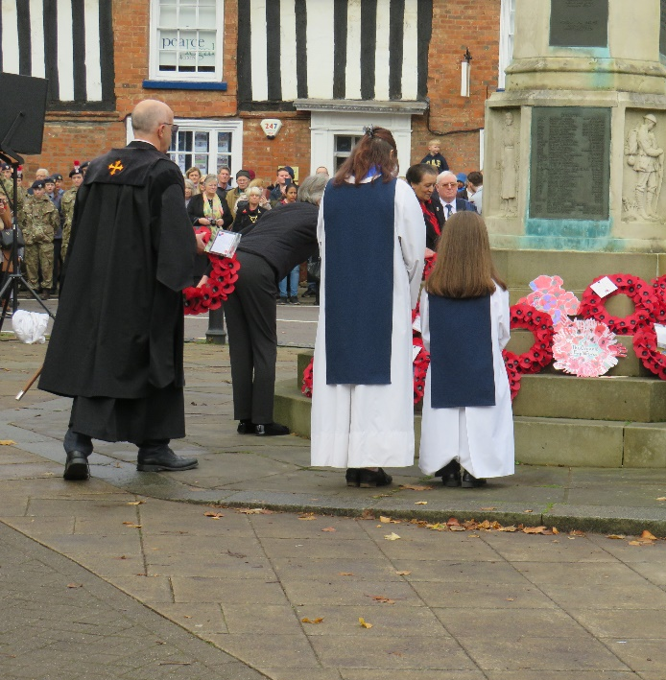
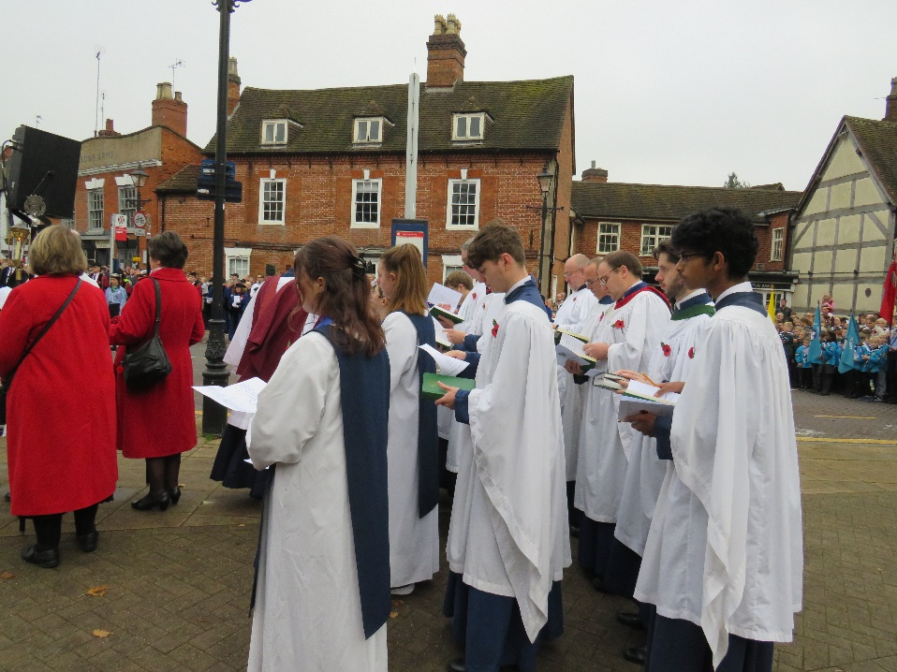

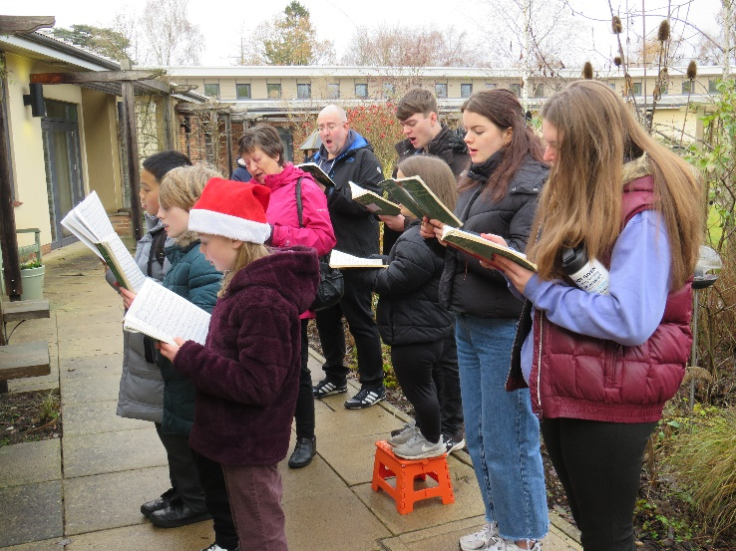
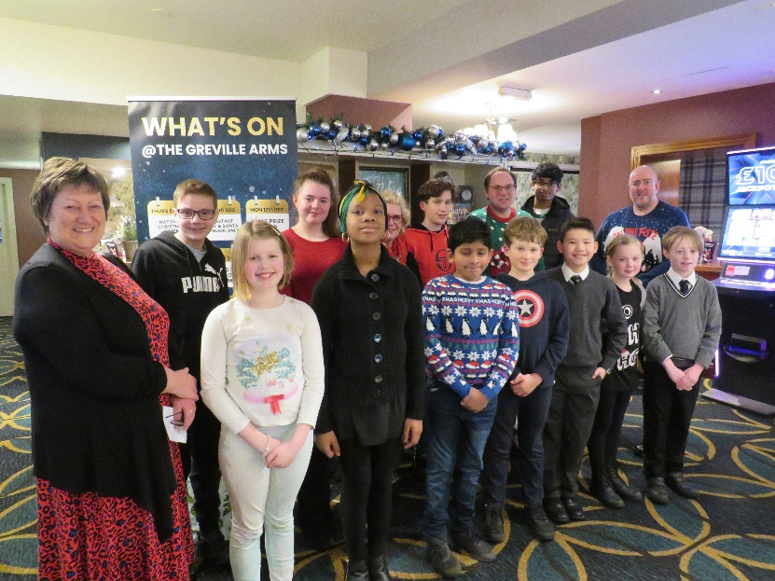

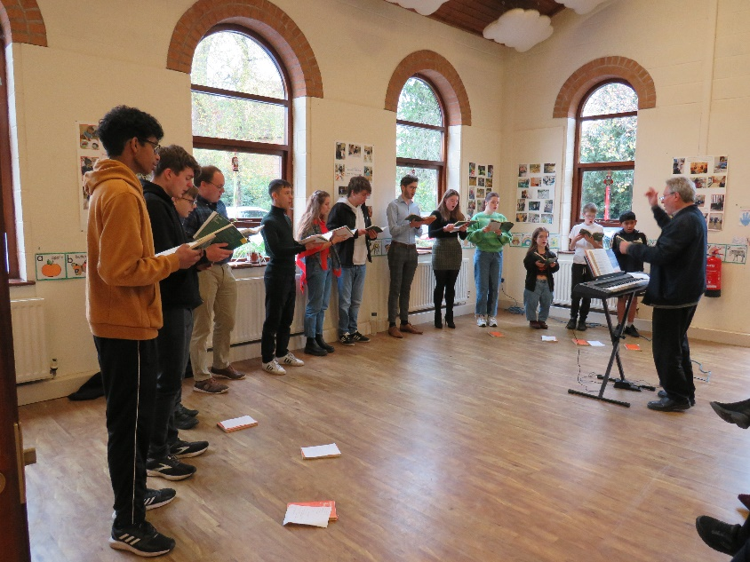

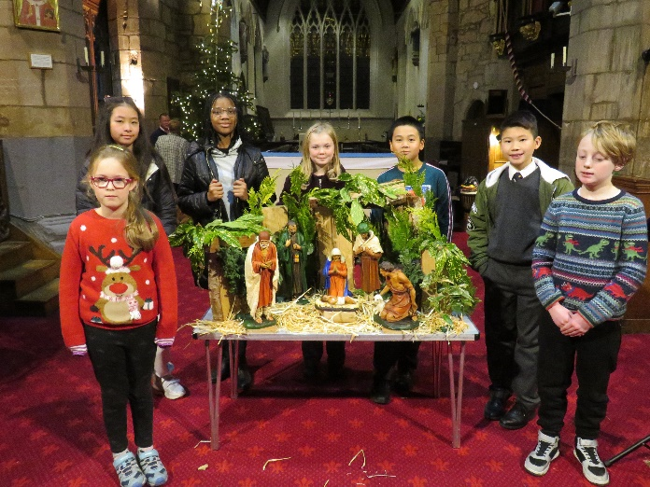

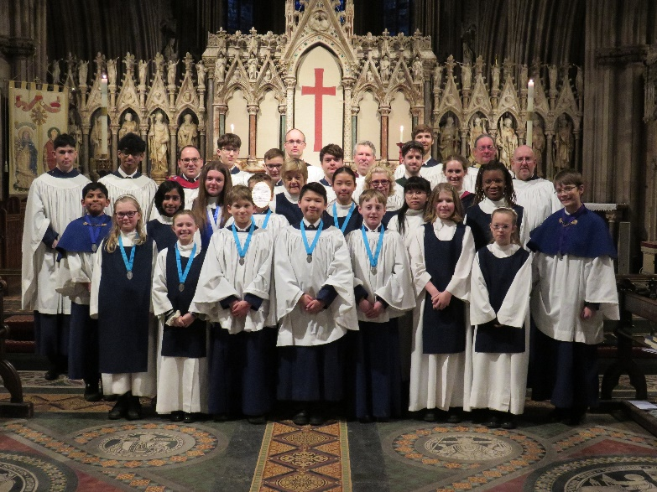
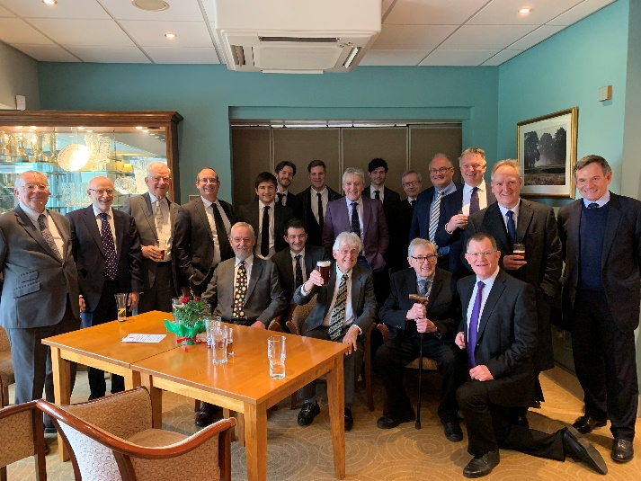

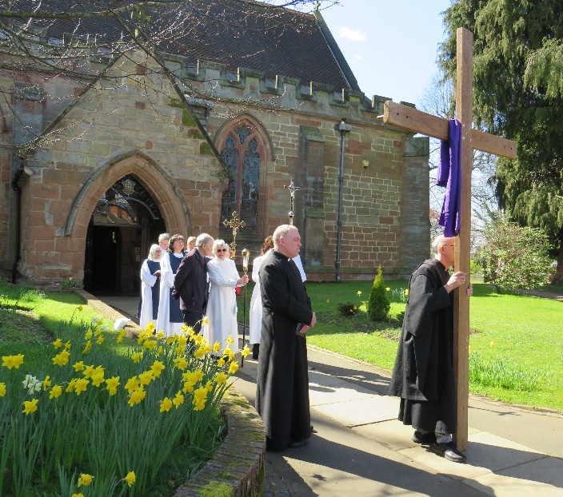
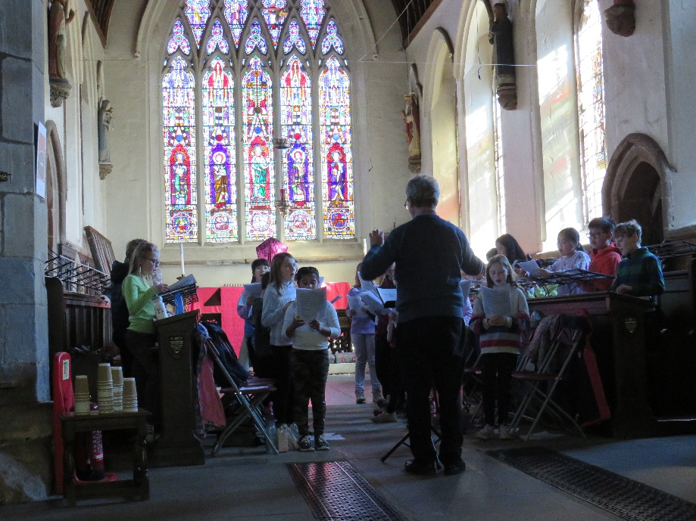

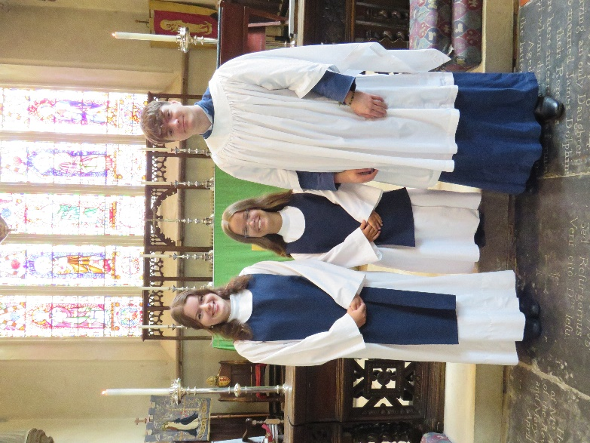
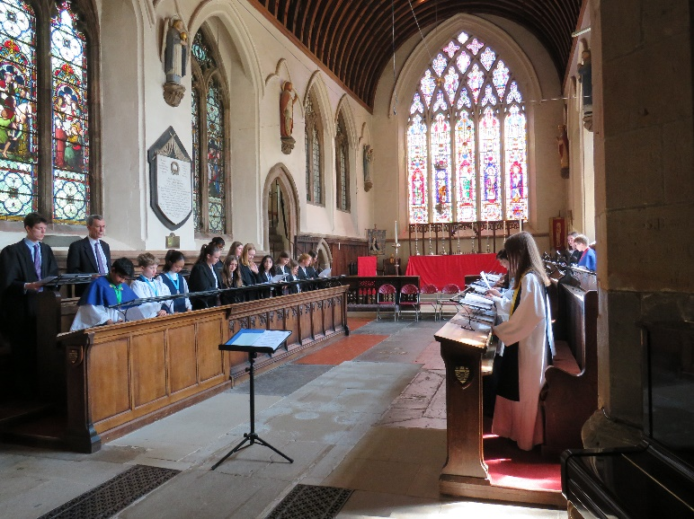
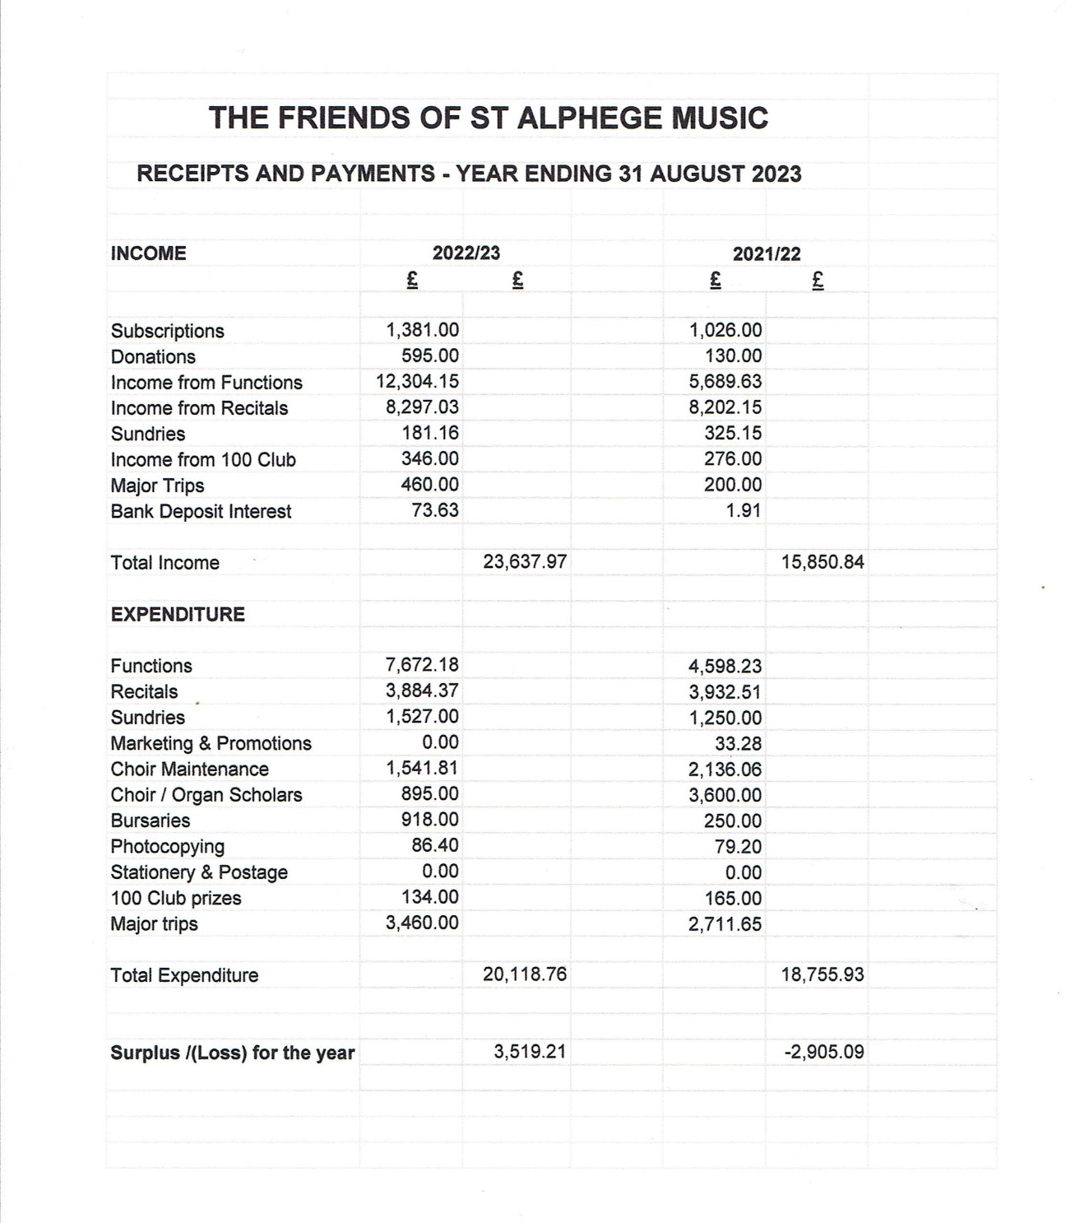
Report from the Treasurer – Pam Price
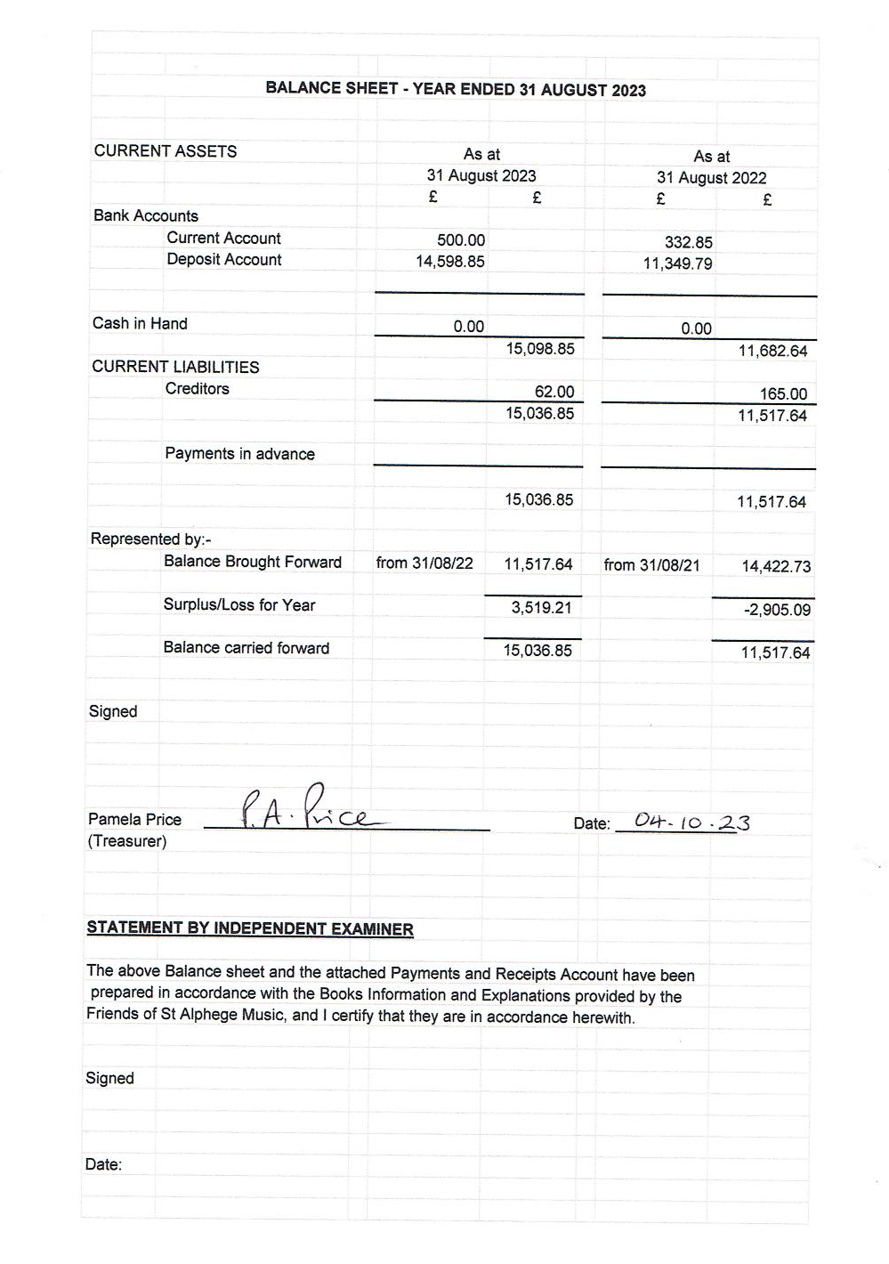

Report from the Membership Secretary – Isabel Baumber

This brief report will give an update about membership numbers for the last year.

Membership numbers remained low last year at 56, of which five were honorary (where I am counting as one member either an individual or a family membership). The previous year’s equivalent numbers were also 56 (with nine honorary members).

Numbers remain low as we continue to rebuild the choirs and FoSAM following the pandemic. I would like to look for more opportunities for encouraging membership during the year ahead, such as trips and exam successes and the corresponding purchase of medals, which we use as a springboard to encourage membership renewal or membership for the first time.

Renewals are due at the end of October each year, and many members have already renewed their membership by paying 2023-24 subscriptions, particularly those who have direct bank payments in place. A huge thank you to those who have been able to do this. We would of course be very pleased if others of last year’s members would renew their subscription at their earliest convenience.

I hope that the reports in this booklet and delivered at this AGM give a full picture of the range of events we have put on and the strength of the choirs, which is what your membership supports.

I would like to encourage our supporters to use standing orders wherever possible, to register with us for gift aid if they are taxpayers, and to provide email addresses and consent for us to use them so that we can keep in touch more about forthcoming events and activities at St Alphege.

Lastly, I would like to take a moment to remember some of the long-standing members who are no longer with us – we have lost some key supporters over the last couple of years. May they rest in peace.

Thank you to all members for your ongoing support.

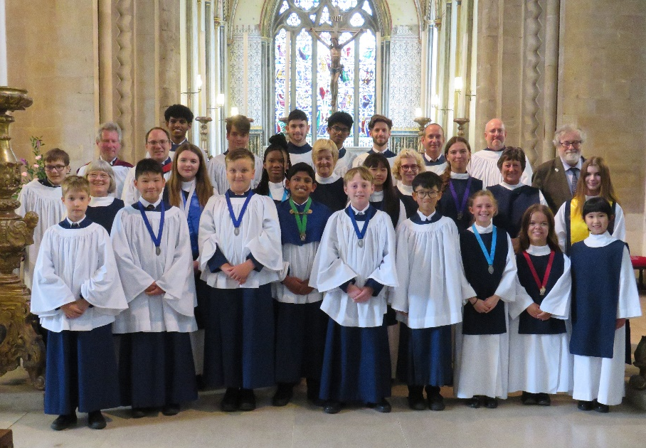

www.solihullparish.org.uk
www.facebook.com/FriendsofStAlphegeMusic
Twitter @StAlphegeMusic

