

All Age Eucharist
on the Fourth Sunday after Trinity

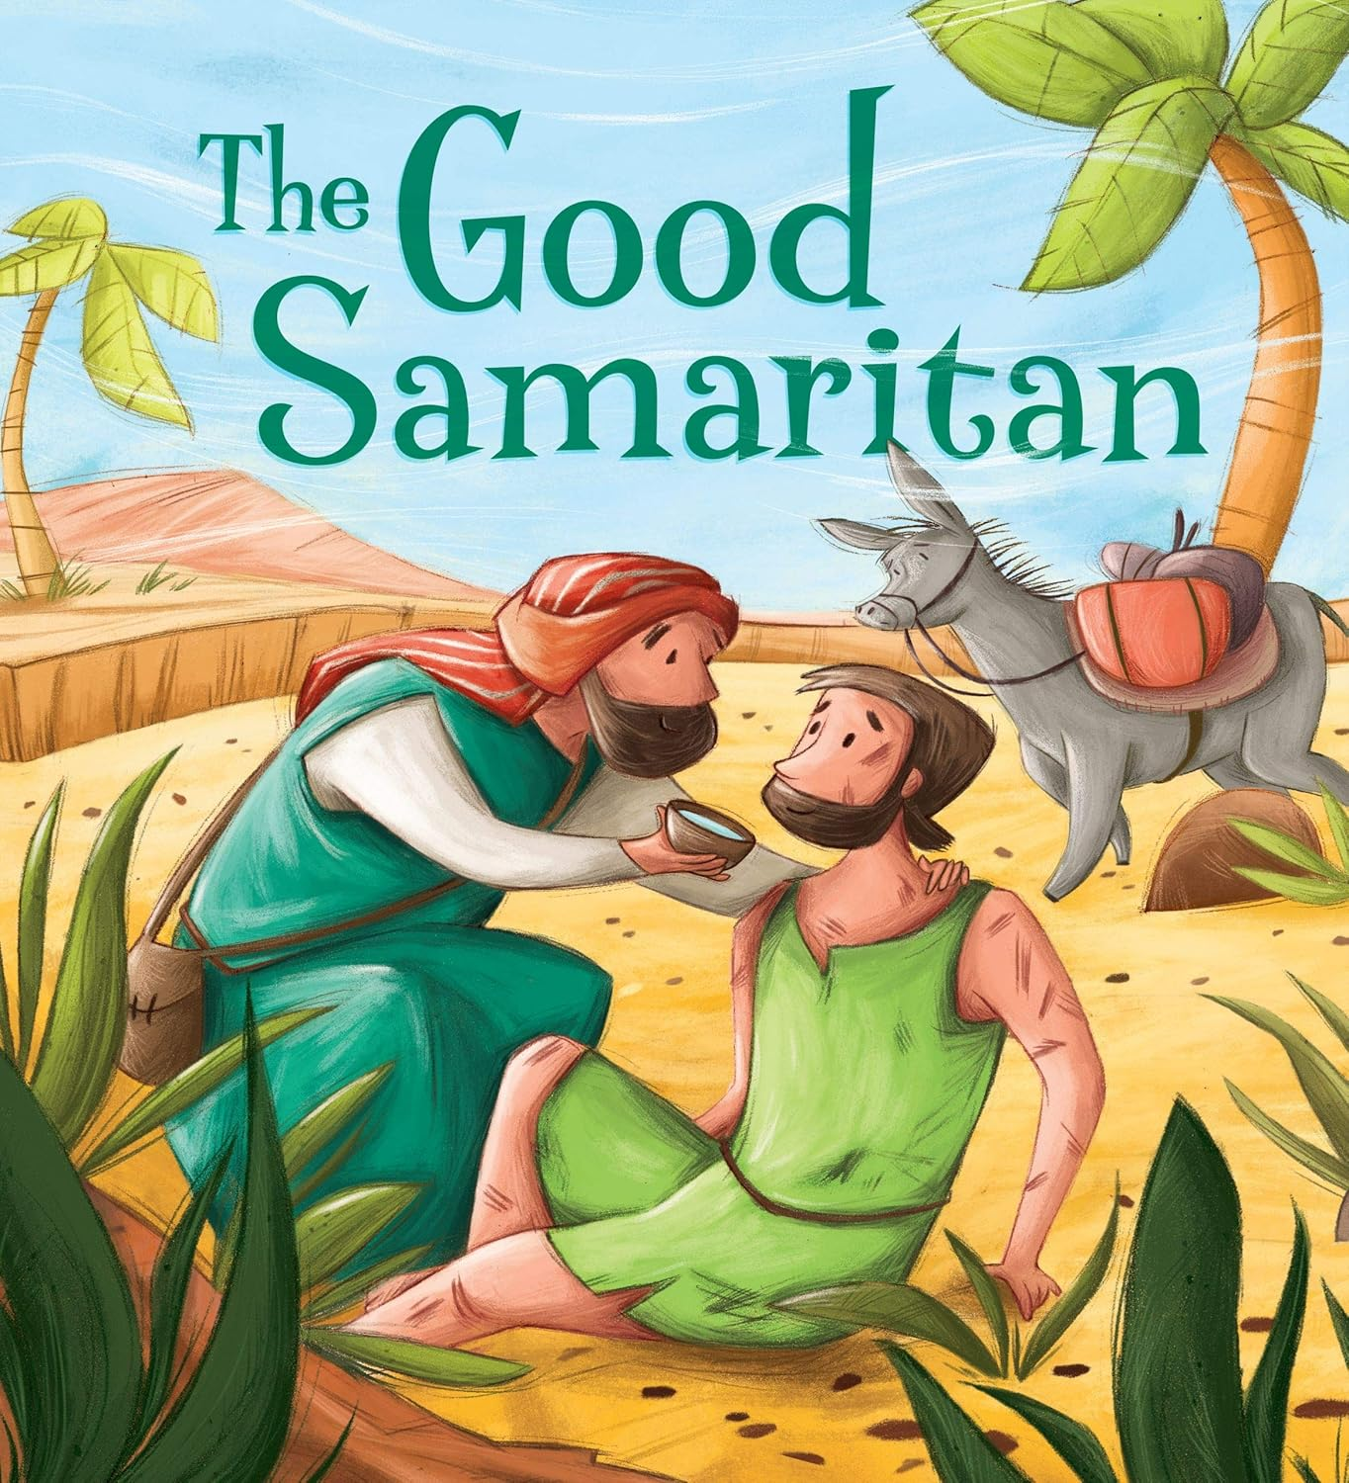

St Alphege Parish Church, Solihull

Sunday 13th July 2025 at 9.15am

Song
GATHERING HYMN – HON 112 Come, now is the time to worship

THE GREETING
In my head (touch head)
in my heart (touch heart)
and all around me (touch shoulders one by one)
Jesus is here (open hands in front, facing upwards)
Amen.

We say together:
All: In my head (touch head)
in my heart (touch heart)
and all around me (touch shoulders one by one)
Jesus is here (open hands in front, facing upwards)
Amen.

Grace, mercy and peace
from God our Father
and the Lord Jesus Christ
be with you.

All and also with you.

Please sit
The President introduces the service.

WE SAY SORRY

God’s Spirit lives in us in order that our lives might bear good fruit
but we recognise that this is not always the case;
that sometimes the fruit we are known by is not good,
that sometimes our lives bear little or no fruit

We keep a moment of stillness.

God of Love, we are sorry for the times we have been unloving.
God of Joy, we are sorry for the times we have chosen to be miserable.
God of Peace, we are sorry for the times we have not borne your peace.
All sing Jesus Lord have mercy on us,
Jesus Lord have mercy on us,
Jesus Lord have mercy on us,
Have mercy on us all.

God of Patience, we are sorry for the times we have been impatient.
God of Kindness, we are sorry for the times we have been unkind.
God of Goodness, we are sorry for the times we have failed to do good.
All sing Christ our Lord have mercy on us,
Christ our Lord have mercy on us,
Christ our Lord have mercy on us,
Have mercy on us all.

God of Faithfulness, we are sorry for the times we have been unfaithful.
God of Gentleness, we are sorry for the times we have been forceful.
God of Order, we are sorry for the times we have lacked self-control.
All sing Jesus Lord have mercy on us,
Jesus Lord have mercy on us,
Jesus Lord have mercy on us,
Have mercy on us all.

WORDS OF FORGIVENESS

Lord God, send your Holy Spirit to fall afresh on us – that, turning to you, we may know your love, your forgiveness, and your renewal.
All Amen.
COLLECT PRAYER

Gracious Father,
by the obedience of Jesus
you brought salvation to our wayward world:
draw us into harmony with your will,
that we may find all things restored in him,
our Saviour Jesus Christ.

All Amen.

THE GOSPEL ACCLAMATION – HON 726 When I needed a neighbour vv1,2,4,5

Junior Choristers sit in the nave of the church
spel
THE GOSPEL READING: Luke 10: 25-37

THE TALK

WE BELIEVE
Please stand
Let us declare our faith in God.

All We believe in God the Father,
from whom every family
in heaven and on earth is named.

We believe in God the Son,
who lives in our hearts through faith,
and fills us with his love.

We believe in the Holy Spirit,
who strengthens us
with power from on high.

We believe in one God;
Father, Son and Holy Spirit.
Amen.

PRAYERS

THE PEACE

Peace to you from God our heavenly Father.
Peace from his Son Jesus Christ who is our peace.
Peace from the Holy Spirit, the life-giver.

The peace of the Lord be always with you.

All And also with you.

We remain in our places and offer one another a sign of peace.

Junior Choristers return to sit in the chancel
OFFERTORY SONG – HON 383 Let us build a house

PREPARATION OF THE TABLE
Blessed be God,
who feeds the hungry,
who raises the poor,
who fills our praise.
All Blessed be God for ever.

THE EUCHARISTIC PRAYER
The Lord is here
All His Spirit is with us.

Lift up your hearts.
All We lift them to the Lord.

Let us give thanks to the Lord our God.
All It is right to give thanks and praise.

1st Young Person Why is it right to give thanks and praise?
All Listen, and we will hear

Lord of all life,
you created the universe,
where all living things reflect your glory.
You give us this great and beautiful earth,
to discover and to cherish.
You give us the fish in the sea,
the birds of the air,
and every plant and tree;
the life that sleeps in the winter earth,
and awakens again in the spring.

You made us all, each wonderfully different,
to join with the angels and sing your praise:
All sing Holy, Holy, Holy Lord, God of pow’r and God of might:
heaven and earth, heaven and earth are full of your glory,
your pow’r and might.
Hosanna, hosanna, hosanna in the highest heav’ns.
Hosanna, hosanna, hosanna in the highest heav’ns.

Blessed, blessed is he who comes,
blessed, blessed is he who comes;
blessed is he, blessed is he
who comes in the name of the Lord.
Hosanna, hosanna, hosanna in the highest heav’ns.
Hosanna, hosanna, hosanna in the highest heav’ns.

Please sit

We thank you, loving Father,
because, when we turned away,
you sent Jesus, your Son.
He gave his life for us on the cross
and shows us the way to live.
Send your Holy Spirit
that these gifts of bread and wine
may be for us Christ’s body and his blood.

2nd Young Person Why do we share this bread and wine?
All Listen, and we will hear

On the night before he died,
when darkness had fallen, Jesus took bread.
He gave thanks, broke it,
and shared it with his disciples, saying:
‘This is my body, given for you. Do this to remember me.’

After they had eaten, he took the cup of wine,
gave thanks, and shared it with his disciples, saying:
‘This is my blood, poured out for you and for many, for the forgiveness of sins.’

So Father, with this bread and this cup
we celebrate his love, his death, his risen life.
As you feed us with these gifts,
send your Holy Spirit, and change us more and more
to be like Jesus our Saviour.

3rd Young Person How do we follow Jesus Christ?
All Listen, and we will hear

Help us, Father, to love one another,
as we look forward to that day when suffering is ended,
and all creation is gathered in your loving arms.

And now with St Alphege… and all your saints
we give you glory, through Jesus Christ, in the strength of the Spirit,
today and for ever.

All Amen.

THE LORD’S PRAYER
As God's children, loved and cherished, let us pray as Jesus taught us.

Our Father in heaven,
hallowed be your name,
your kingdom come,
your will be done,
on earth as in heaven.
Give us today our daily bread.
Forgive us our sins
as we forgive those who sin against us.
Lead us not into temptation
but deliver us from evil.
For the kingdom, the power
and the glory are yours
now and for ever.
Amen.
BREAKING OF THE BREAD

The president breaks the consecrated bread.

We break this bread
to share in the body of Christ.

All Though we are many, we are one body,
because we all share in one bread.

All join in singing the words in bold:

Lamb of God, you take away the sin of the world: have mercy on us.
Lamb of God, you take away the sin of the world: have mercy on us.
Lamb of God, you take away the sin of the world: grant us peace.
GIVING OF COMMUNION
Come to this table, not because you must,
but because you may,
not because you are strong,
but because you are weak.
Come, not because any goodness of your own gives you a right to come,
but because you need mercy and help.
Come, because you love the Lord a little
and would like to love him more.
Come, because he loved you
and gave himself for you.

We receive communion.
We are all invited to draw near to God today.

If you, or your children, regularly receive the bread and wine at any Christian church,
you are most welcome to do so today.

If you do not usually receive the bread and wine, or prefer not to do so today,
you are invited to come forward to receive a prayer of blessing.
If you do this, you may want to hold your hands together in prayer
so that we know your intention.

The Junior Choristers sing “Christ be in my waking” by Stuart Townend and Simon Brading
– SoF 2244

Christ be in my waking,
as the sun is rising,
in my day of working,
with me every hour.
Christ be in my resting,
as the day is ending,
calming and refreshing,
watching through the night.

Christ be in my thinking,
and my understanding,
guarding me from evil,
walking in the light.
Christ be in my speaking,
every word a blessing,
pure and not deceiving,
grace to all who hear.

Chorus
Jesus, this is my devotion,
all my life to know you,
every day to walk with you.
Saviour, you’re my deepest longing,
you’re the one I live for,
teach me Lord, to walk with you.

Christ be in my gladness
for the joy of living,
thankful for the goodness
of the Father’s hand.
Christ be in my sorrow,
and my day of darkness,
knowing that I follow
in the steps he trod.
Chorus

Christ when hope has faded,
nothing left to cling to,
every pleasure jaded,
every well is dry.
Christ the loving shepherd
draws me with his kindness,
leads me from the desert
to the streams of life.
Chorus

Christ be in my waking,
as the sun is rising,
in my day of working,
with me every hour.
Christ be in my resting,
as the day is ending.

© 2011 Thankyou Music/Adm. Kingswaysongs

SONG DURING COMMUNION – HON 485 O God, you search me

PRAYER AFTER COMMUNION
Heavenly Father,
We thank you that you have called us to share the Good News with others.
Be with us as we share all that we know of your love.
Give us courage and wisdom to go wherever you send us.
And, in the sharing of the bread and wine, unite us with one another and with you.
For we are all one in your love.

All Amen
NOTICES AND BANNS
The President gives out any notices and banns of marriage.

Please stand if you are able
FINAL SONG – HON 406 Lord, I lift your name on high

THE BLESSING
May God’s joy be in our hearts
May God’s peace be in our world
May God’s love be known between us
and the blessing of God almighty,
the Father, the Son, and the Holy Spirit,
be among you and remain with you always.

All Amen.
THE DISMISSAL

Go in peace to love and serve the Lord.
All In the name of Christ. Amen.

Growing Disciples, Building Community, Transforming Lives
www.solihullparish.org.uk
linktr.ee/solihullparish

