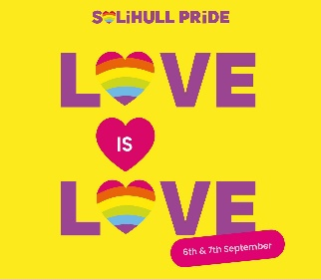
Love is Love

This is the slogan at the heart of the inaugural Solihull Pride weekend taking place 6-7th September organised by Solihull BID. The various events, including a carnival-style parade on the Saturday, are about making Solihull a safe and inclusive place for everyone – including members of the LGBTQi community who have not always felt welcome. With large numbers of residents and visitors expected in the town centre we are extending the visiting hours at St. Alphege, offering a warm welcome and free refreshments. The church will also be designated within the BID publicity as a safe place, where those looking for a quiet and peaceful place, or a listening ear, may find it.
To return to the ‘Love is Love’ phrase, this is intended to emphasize that love, in all its diverse forms, is a universal human experience and should be accepted and respected regardless of the individuals involved or the nature of the relationship. The phrase's meaning extends beyond romantic love to encompass platonic love, familial love, and self-love, suggesting that all expressions of love are valid.
Whilst such a view is attractive in its simplicity, it’s not one that’s universally held by Christian people, indeed I appreciate that within our parish community there is a legitimate diversity of opinion on what is a complex, sensitive, and most often deeply personal subject. Furthermore, our understanding of the Church’s teaching and what it means to faithfully follow Jesus will vary, as this is often coloured by our sense of identity, familial situation, and various life experiences. My own thoughts and feelings on all this have changed significantly over time and I look forward to joining the crowds lining the parade route. Some church members will enthusiastically join the parade, whilst others will find the whole thing deeply troubling. Knowing this to be true, I judge it would be inappropriate to fly a rainbow flag at the church as doing so would alienate some and ironically make us less inclusive.
What we can unite around is the demand for kindness and gentleness – fruit of the Spirit and essential Christian qualities that all Jesus’ followers are called to show to everyone without distinction as an expression of God’s love. Such loving care recognises that we are all made in God’s image, that every life is therefore imbued with immeasurable value, and underpins Christ’s teaching ‘to do unto others as we would have them do to us.’ It is in the knowledge that every church member shares this understanding, and with it the desire to be gentle and kind, that I felt able to guarantee the suitability of the church to the BID team as safe place during the weekend.
As I write these words my thoughts go beyond the Pride weekend to the present horror unfolding in Gaza – to the intolerable hostage situation, widespread hunger, and unjustifiable loss of innocent life. My mind also goes to the ongoing war in Ukraine and many other places across God’s world where people suffer oppression and injustice. Whilst such conflicts are multi-layered and deeply rooted the first step towards peace is obvious. This step lies where it always does, in reflecting more deeply on our common humanity – that what we hold in common is more important than the things that may divide us – along with recognising our own failures and need for grace. Whilst we may not be able to change international situations we can live by these truths, so helping to make Solihull a more generous, inclusive and welcoming place for everyone. The path to the better world God intended is as simple yet demanding as this. May such be our prayer.

