Parish Church of St Alphege Solihull



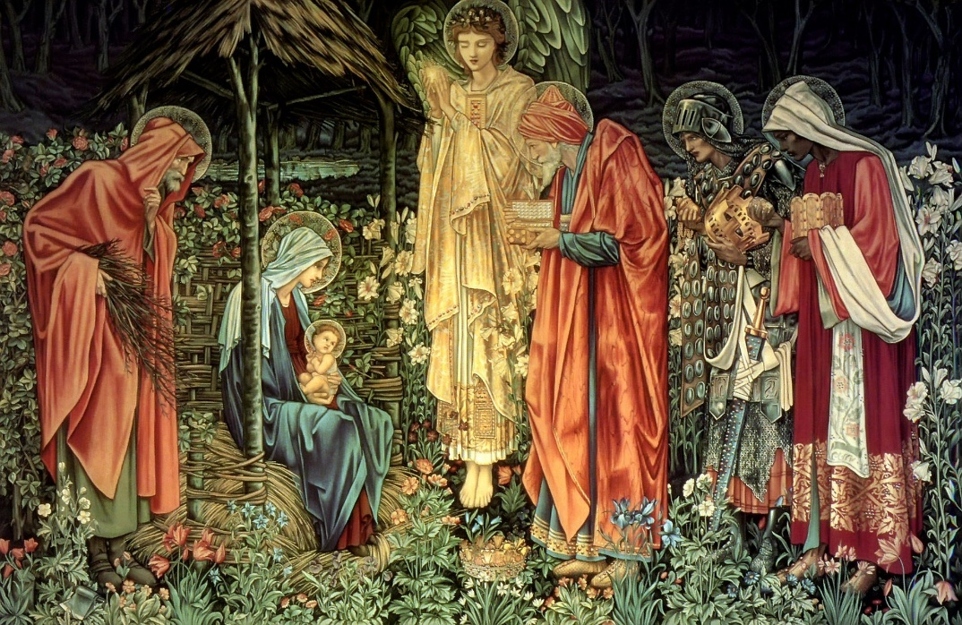
Sung Eucharist
for the Season of Epiphany

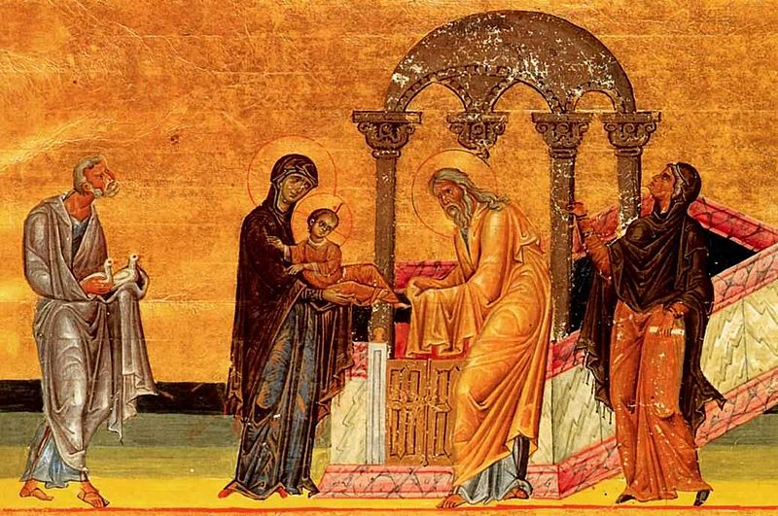
11am Order of Service
for Sundays 4th, 11th,
25th January
& 1st February 2025
(The Feast of the Presentation)

Settings:
January 4th Sumsion in F; 11th Waltham Abbey; 25th Darke in A Minor
February 1st Ireland in C
The president welcomes the people and announces the first hymn.

The Gathering
Processional Hymn
Please see Pewslip
✚ In the name of the Father and of the Son
and of the Holy Spirit.
All Amen.
The Greeting
Blessed are you, Lord our God, King of the universe.
All From the rising of the sun to its setting
your name is proclaimed in all the world.

The Lord of glory be with you.
All And also with you.

The president introduces the service

Prayers of Penitence

The grace of God has dawned upon the world
through our Saviour Jesus Christ,
who sacrificed himself for us
to purify a people as his own.

In the light of this grace let us confess our sins.

We recall the ways in which we have failed to love as Christ taught us…

Lord Jesus, you are mighty God and Prince of peace:
Lord, have mercy.
All Lord, have mercy.

Lord Jesus, you are Son of God and Son of Mary:
Christ, have mercy.
All Christ, have mercy.

Lord Jesus, you are Word made flesh
and splendour of the Father:
Lord, have mercy.
All Lord, have mercy.
Absolution

May God who so loved the world
that he sent his Son to be our Saviour
✚ forgive you your sins
and make you holy to serve him in the world,
through Jesus Christ our Lord.
All Amen.
The Gloria
Coventry Gloria for Feast of the Epiphany. (We all sing the words in bold)

Glory to God, glory in the highest. Peace to his people, peace on earth.
Glory to God, glory in the highest. Peace to his people, peace on earth.
Lord God, heavenly King, almighty God and Father.
Glory to God, glory in the highest. Peace to his people, peace on earth.
We worship you,
Glory in the highest
Give you thanks
Glory in the highest
Praise you for your glory.
Glory to God, glory in the highest. Peace to his people, peace on earth.
Lord Jesus Christ, only Son of the Father,
Lord God, Lamb of God, you take away the sin of the world: have mercy on us,
Have mercy on us;
You are seated at the right hand of the Father: receive our prayer,
Receive our prayer.
Glory to God, glory in the highest. Peace to his people, peace on earth.
Glory to God, glory in the highest. Peace to his people, peace on earth.
For you alone are the Holy One, you alone are the Lord,
You alone are the Most High, Jesus Christ, with the Holy Spirit,
In the glory of God, the glory of God the Father.
Glory to God, glory in the highest. Peace to his people, peace on earth.
Amen.
On the remaining Sundays we sing this setting by Martin How:

Glory to God in the highest, and peace to his people on earth.
Glory to God in the highest, and peace to his people on earth.
Lord God, heavenly King, almighty God and Father.
Glory to God in the highest, and peace to his people on earth.
We worship you, we give you thanks, we praise you for your glory.
Glory to God in the highest, and peace to his people on earth.

Lord Jesus Christ, only Son of the Father,
Lord God, Lamb of God, you take away the sin of the world:
have mercy on us, have mercy on us;
you are seated at the right hand of the Father:
receive our prayer, receive our prayer.

For you alone are the Holy One, you alone are the Lord,
Glory to God in the highest, and peace to his people on earth.
You alone are the Most High, Jesus Christ,
with the Holy Spirit, in the glory of God the Father.
Glory to God in the highest, and peace to his people on earth.
Amen. Amen. Amen.

The Collect
Please remain standing

Grateful for the glory revealed through God made flesh, let us pray.

A moment of silence before the Collect is read (printed on the Pewslip).

The Liturgy of the Word
First Reading
Please see Pewslip

At the end of the reading:

This is the word of the Lord.
All Thanks be to God.
The Psalm
Please see Pewslip

Second Reading
Please see Pewslip

At the end of the reading:

This is the word of the Lord.
All Thanks be to God.

The Gospel

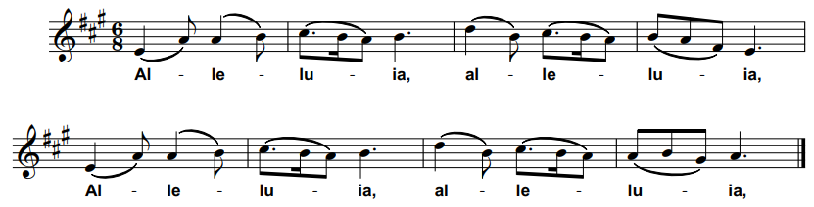
Please stand. The Choir and Congregation sing the Gospel acclamation.

Christ was revealed in flesh, proclaimed among the nations
and believed in throughout the world.

On the Feast of the Presentation:

This child is the light to enlighten the nations,
And the glory of your people Israel.

Hear the Gospel of our Lord Jesus Christ according to N.
All Glory to you, O Lord.

At the end of the Gospel reading:

This is the Gospel of the Lord.
All Praise to you, O Christ.

Sermon
The Creed
Please stand
Do you believe and trust in God the Father,
source of all being and life,
the one for whom we exist?
All We believe and trust in him.

Do you believe and trust in God the Son,
who took our human nature,
died for us and rose again?
All We believe and trust in him.

Do you believe and trust in God the Holy Spirit,
who gives life to the people of God
and makes Christ known in the world?
All We believe and trust in him.

This is the faith of the Church.
All This is our faith.
We believe and trust in one God,
Father, Son and Holy Spirit.
Amen.

Prayers of Intercession

This response may be used

Lord of glory,
All Hear our prayer

The prayers may conclude as follows:

Merciful Father,
All Accept these prayers
For the sake of your Son,
Our Saviour Jesus Christ. Amen.

The Liturgy of the Sacrament

The Peace

Our Saviour Christ is the Prince of Peace.
Of the increase of his government and peace
there shall be no end.

On the Feast of the Presentation only:

In the tender mercy of our God
the dayspring from on high has broken upon us,
to give light to those who dwell in darkness
and in the shadow of death
and to guide our feet into the way of peace.

The peace of the Lord be always with you
All and also with you.
Offertory Hymn
Please see Pewslip.

Prayer at the Preparation of the Table
Blessed be God,
by whose grace creation is renewed,
by whose love heaven is opened,
by whose mercy we offer our sacrifice of praise.
All Blessed be God for ever.
The Eucharistic Prayer

We remain standing, as able.
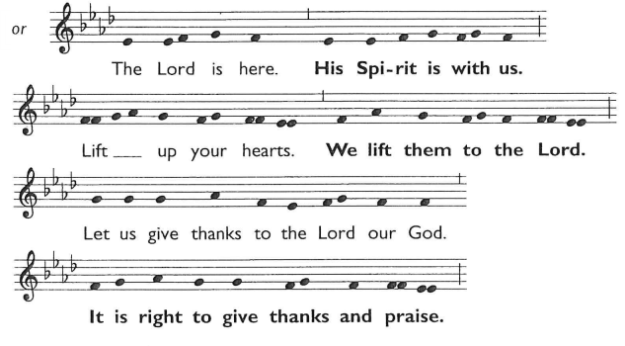
The Lord is here.
All His Spirit is with us.
Lift up your hearts.
All We lift them to the Lord.

Let us give thanks to the Lord our God.
All It is right to give thanks and praise.
Father, we give you thanks and praise
through your beloved Son Jesus Christ, your living Word,
through whom you have created all things;
who was sent by you in your great goodness to be our Saviour.
By the power of the Holy Spirit he took flesh;
as your Son, born of the blessed Virgin,
he lived on earth and went about among us;
he opened wide his arms for us on the cross;
he put an end to death by dying for us;
and revealed the resurrection by rising to new life;
so he fulfilled your will and won for you a holy people.

From the Epiphany until the Presentation:

And now we give you thanks
because, in the incarnation of the Word,
a new light has dawned upon the world,
that all the nations may be brought out of darkness
to see the radiance of your glory.

On the Feast of the Presentation:

And now we give you thanks
because, appearing in the temple, he comes near to us in judgement;
the Word made flesh searches the hearts of all your people
and brings to light the brightness of your splendour.

The Choir sings the Sanctus and Benedictus:
Holy, holy, holy, Lord God of hosts.
Heav’n and earth are full of Thy glory
Glory be to Thee, O Lord most High.
Blessed is He that cometh in the Name of the Lord.
Hosanna in the highest.

Lord, you are holy indeed, the source of all holiness;
grant that by the power of your Holy Spirit,
and according to your holy will, these gifts of bread and wine
may be to us the body and blood of our Lord Jesus Christ;
who, in the same night that he was betrayed,
took bread and gave you thanks;
he broke it and gave it to his disciples, saying:
Take, eat; this is my body which is given for you;
do this in remembrance of me.
In the same way, after supper
he took the cup and gave you thanks;
he gave it to them, saying:
Drink this, all of you; this is my blood of the new covenant,
which is shed for you and for many for the forgiveness of sins.
Do this, as often as you drink it, in remembrance of me.

Great is the mystery of faith:
All Christ has died:
Christ is risen:
Christ will come again.

And so, Father, calling to mind his death on the cross,
his perfect sacrifice made once for the sins of the whole world;
rejoicing in his mighty resurrection and glorious ascension,
and looking for his coming in glory,
we celebrate this memorial of our redemption.

As we offer you this our sacrifice of praise and thanksgiving,
we bring before you this bread and this cup
and we thank you for counting us worthy
to stand in your presence and serve you.
Send the Holy Spirit on your people
and gather into one in your kingdom
all who share this one bread and one cup,
so that we, in the company of St. Alphege and all the saints,
may praise and glorify you for ever,
through Jesus Christ our Lord;
by whom, and with whom, and in whom,
in the unity of the Holy Spirit,
all honour and glory be yours, almighty Father,
for ever and ever.
All Amen.
The Lord’s Prayer
We sit or kneel
Rejoicing in the God who draws all nations to worship at his throne,
we pray the prayer our Saviour taught us, in the language of our hearts.

Our Father, who art in heaven…

Our Father in heaven…

我們在天上的父…

Pater noster, qui es in caelis…

हे हमारे पिता, तू जो स्वर्ग में है…

Vater unser im Himmel…

Amen.

The Breaking of Bread
The celebrant breaks the consecrated bread.

Every time we eat this bread and drink this cup,
All we proclaim the Lord’s death until he comes.

The Invitation
God’s holy gifts, for God’s holy people.
All Jesus Christ is holy,
Jesus Christ is Lord,
to the glory of God the Father.

We are all invited to draw near to God today. If you, or your children, regularly receive the bread and wine at any Christian church, you are most welcome to do so. If you do not usually receive the bread and wine, or prefer not to do so today, you are invited to come forward to receive a prayer of blessing. If you do this, you may want to hold your hands together in prayer so that we know your intention. Thank you.
Agnus Dei

Whilst those helping with the administration receive, the Choir sings the Agnus Dei.
(On the 11th the words ‘O Lamb of God’ are replaced by ‘Jesus, Lamb of God’).

O Lamb of God that takest away the sins of the world, have mercy upon us.
O Lamb of God that takest away the sins of the world, have mercy upon us.
O Lamb of God that takest away the sins of the world, grant us Thy peace.

The Giving of Communion
The choir sings an anthem during the Distribution

Communion Hymn
Please see Pewslip
The choir receives whilst all sing (remaining seated)

Prayer After Communion

The president reads the Post Communion Prayer from the Pewslip.

We pray together:
All Father of all, we give you thanks and praise,
that when we were still far off
you met us in your Son and brought us home.
Dying and living, he declared your love,
gave us grace, and opened the gate of glory.
May we who share Christ’s body live his risen life;
we who drink his cup bring life to others;
we whom the Spirit lights give light to the world.
Keep us firm in the hope you have set before us,
so we and all your children shall be free,
and the whole earth live to praise your name;
through Christ our Lord. Amen.
Dismissal
Notices

Final Hymn
Please see Pewslip

The Blessing

Christ the Son of God perfect in you the image of his glory
and gladden your hearts with the good news of his kingdom.
and the blessing of God almighty,
the Father, the Son, and the Holy Spirit,
be among you and remain with you always.
All Amen.

On the Feast of the Presentation:

Christ the Son of God, born of Mary,
fill you with his grace to trust his promises and obey his will;
and the blessing of God almighty,
the Father, the Son, and the Holy Spirit,
be among you and remain with you always.
All Amen.

The Sending
Go in the light and peace of Christ.
All Thanks be to God.

Organ voluntary (please see Pewslip for details).

Growing Disciples, Building Community, Transforming Lives
www.solihullparish.org.uk
linktr.ee/solihullparish

