Parish Church of St Alphege Solihull

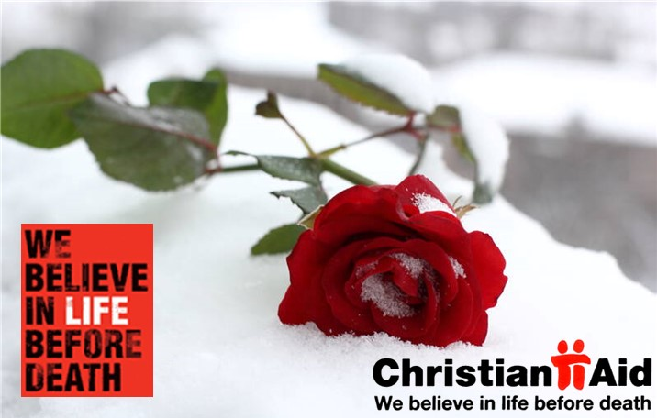

Sung Eucharist for
Easter 5 & 6

3rd and 10th May 2026
(Christian Aid Week 10-16 May)

11am
Order of Service

Setting:
Haugen, Creation Gloria; Stanford in Bb & F (3/5), Sumsion in F (10/5)
The Gathering

The president welcomes the congregation, including those online.

Processional Hymn
3rd May HON 19 ‘All my hope’
10th May HON 77 ‘Breathe on me’

The Greeting
✚ In the name of the Father and of the Son
and of the Holy Spirit.
All Amen.

Grace, mercy and peace from God our Father
and the Lord Jesus Christ be with you.
All and also with you.

Alleluia. Christ is risen.
All He is risen indeed. Alleluia.

Words of introduction may be said.
The Confession
What God has prepared for those who love him, he has revealed to us through the Spirit; for the Spirit searches everything.
Therefore, let us in penitence open our hearts to the Lord,
who has prepared good things for those who love him.

Lord Jesus, you raise us to new life.
Lord, have mercy.
All Lord, have mercy.

Lord Jesus, you forgive us our sins.
Christ, have mercy.
All Christ, have mercy.

Lord Jesus, you feed us with the living bread.
Lord, have mercy.
All Lord, have mercy.
The Absolution
President: May the God of love and power
✚ forgive you and free you from your sins,
heal and strengthen you by his Spirit,
and raise you to new life in Christ our Lord. Amen.

The Gloria
The Choir and Congregation stand to sing the Gloria.

Glory to God in the highest,  And peace to his people on earth.  Lord God, heavenly King,  almighty God and Father.  We worship you,  we give you thanks,  we praise you for your glory.  Glory to God in the highest,  And peace to his people on earth.  Lord Jesus Christ,  only Son of the Father,  Lord God, Lamb of God,  you take away the sin of the world:  have mercy on us, | you are seated at the right hand  of the Father:  receive our prayer.  Glory to God in the highest,  And peace to his people on earth.  For you alone are the Holy One,  you alone are the Lord.  You alone are the Most High,  Jesus Christ, with the Holy Spirit,  in the glory of God the Father.  Amen! Amen!  Glory to God in the highest,  And peace to his people on earth.  Music by Marty Haugen

The Collect
The president prays the Collect for the Day.

3rd May Almighty God,
who through your only-begotten Son Jesus Christ
have overcome death and opened to us the gate of everlasting life: grant that, as by your grace going before us
you put into our minds good desires,
so by your continual help we may bring them to good effect;
through Jesus Christ our risen Lord,
who is alive and reigns with you,
in the unity of the Holy Spirit,
one God, now and for ever.
All Amen.

10th May God our redeemer,
you have delivered us from the power of darkness
and brought us into the kingdom of your Son:
grant, that as by his death he has recalled us to life,
so by his continual presence in us he may raise us
to eternal joy;
through Jesus Christ your Son our Lord,
who is alive and reigns with you,
in the unity of the Holy Spirit,
one God, now and for ever.
All Amen.

The Liturgy of the Word
First Reading
3rd May - Acts 7.55-end
10th May – Acts 17.22-31

At the end of the reading:
This is the word of the Lord.
All Thanks be to God.

Gradual Psalm
We stand to sing:
3rd May - Psalm 31.1-5
10th May - Psalm 66.7-end

Second Reading
3rd May – 1 Peter 2.2-10
10th May – 1 Peter 3.13-end
At the end of the reading:
This is the word of the Lord.
All Thanks be to God.
The Gospel
3rd May: John 14.1-14
10th May: John 14.15 - 21

Please stand for our Gospel reading. We sing the Gospel acclamation.
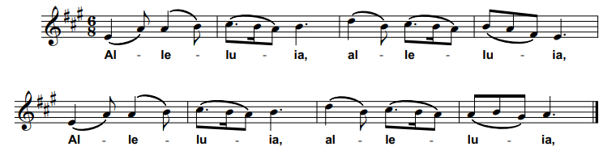
Alleluia, alleluia, alleluia, alleluia.
All Alleluia, alleluia, alleluia, alleluia.

I am the first and the last, says the Lord, and the living one;
I was dead, and behold I’m alive for evermore.
All Alleluia, alleluia, alleluia, alleluia.

Hear the Gospel of our Lord Jesus Christ according to John
All Glory to you, O Lord.

At the end of the Gospel reading:

This is the Gospel of the Lord.
All Praise to you, O Christ.

Sermon

Creed
Let us declare our faith
in the resurrection of our Lord Jesus Christ.
All Christ died for our sins
in accordance with the Scriptures;
he was buried;
he was raised to life on the third day
in accordance with the Scriptures;
afterwards he appeared to his followers,
and to all the apostles:
this we have received,
and this we believe. Amen.

Prayers of Intercession
This response may be used:

Lord, in your mercy.
All hear our prayer.

The prayers conclude:

Merciful Father,
All Accept these prayers for the sake of your Son
our saviour Jesus Christ.
Amen.

The Liturgy of the Sacrament
The Peace
We stand.

The risen Christ came and stood among his disciples
and said, ‘Peace be with you.’
Then were they glad when they saw the Lord. Alleluia.

The peace of the Lord be always with you.
All And also with you.

Offertory Hymn
3rd May HON 333 ‘Jesus lover of my soul’
10th May HON 324 ‘I the Lord of sea and sky’

Prayer at the Preparation of the Table
Be present, be present,
Lord Jesus Christ,
our risen high priest;
make yourself known in the breaking of bread.
All Amen.
The Eucharistic Prayer

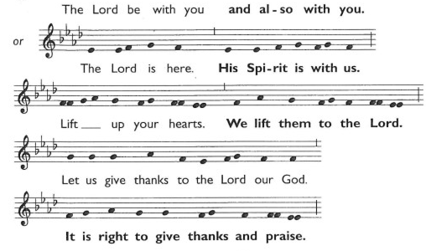

It is indeed right, our duty and our joy,
always and everywhere to give you thanks,
almighty and eternal Father,
and in these days of Easter
to celebrate with joyful hearts
the memory of your wonderful works.
For by the mystery of his passion
Jesus Christ, your risen Son,
has conquered the powers of death and hell
and restored in men and women the image of your glory.
He has placed them once more in paradise
and opened to them the gate of life eternal.
And so, in the joy of this Passover,
earth and heaven resound with gladness,
while angels and archangels and the powers of all creation
sing for ever the hymn of your glory:

The Choir sings the Sanctus and Benedictus.

Holy, Holy, Holy Lord.
God of power and might.
Heaven and earth are full of your glory,
Hosanna in the highest.
Blessed is he who comes in the name of the Lord. Hosanna in the highest.

We sit.

We praise and bless you, loving Father,
through Jesus Christ, our Lord;
and as we obey his command,
send your Holy Spirit,
that broken bread and wine outpoured
may be for us the body and blood of your dear Son.

On the night before he died he had supper with his friends
and, taking bread, he praised you.
He broke the bread, gave it to them and said:
Take, eat; this is my body which is given for you;
do this in remembrance of me.

When supper was ended he took the cup of wine.
Again he praised you, gave it to them and said:
Drink this, all of you;
this is my blood of the new covenant,
which is shed for you and for many for the forgiveness of sins.
Do this, as often as you drink it, in remembrance of me.

So, Father, we remember all that Jesus did,
in him we plead with confidence his sacrifice
made once for all upon the cross.

Bringing before you the bread of life and cup of salvation,
we proclaim his death and resurrection
until he comes in glory.

Jesus Christ is Lord:
All Lord, by your cross and resurrection
you have set us free.
You are the Saviour of the world.

Lord of all life,
help us to work together for that day
when your kingdom comes
and justice and mercy will be seen in all the earth.

Look with favour on your people,
gather us in your loving arms
and bring us with Alphege, Helen, Michael and all the saints
to feast at your table in heaven.

Through Christ, and with Christ, and in Christ,
in the unity of the Holy Spirit,
all honour and glory are yours, O loving Father,
for ever and ever.
All Amen.

The Lord’s Prayer
Rejoicing in God’s new creation,
we pray the prayer our Saviour taught us, in the language of our hearts.

Our Father, who art in heaven…

Our Father in heaven…

我們在天上的父…

Tatăl nostru, Carele ești în ceruri…

हे हमारे पिता, तू जो स्वर्ग में है…

Vater unser im Himmel…

Amen.

The Breaking of Bread
The celebrant breaks the consecrated bread.

Jesus says, I am the bread of life,
whoever eats this bread will live for ever.
All Lord, our hearts hunger for you;
give us this bread always.
The Invitation

Alleluia. Christ our Passover is sacrificed for us.
All Therefore let us keep the feast. Alleluia.

The Giving of Communion
Whilst those helping with the administration receive, the choir sings the Agnus Dei.

Agnus Dei

O Lamb of God that takest away the sins of the world,
have mercy upon us.

O Lamb of God that takest away the sins of the world,
have mercy upon us.

O Lamb of God that takest away the sins of the world,
grant us Thy peace.

We are all invited to draw near to God today.
If you, or your children, regularly receive the bread and wine at any Christian church, you are most welcome to do so. If you do not usually receive the bread and wine, or prefer not to do so today, you are invited to come forward to receive a prayer of blessing. If you do this, you may want to hold your hands together in prayer so that we know your intention. Thank you.

The choir sings the anthem during the distribution.
On 3rd May: O taste and see – Vaughan Williams
On 10th May: If ye love me – Tallis
Communion Hymn
3rd May HON 282 ‘How sweet the name’
10th May HON 69 ‘Blest are the pure in heart’

Post-Communion Prayer
The president will pray this week’s post-communion prayer.

3rd May

Eternal God,
whose Son Jesus Christ is the way, the truth, and the life:
grant us to walk in his way,
to rejoice in his truth,
and to share his risen life;
who is alive and reigns, now and for ever.
All Amen.

10th May

God our Father,
whose Son Jesus Christ gives the water of eternal life:
may we thirst for you, the spring of life and source of goodness,
through him who is alive and reigns,
now and for ever.
All Amen.

All God of truth,
we have seen with our eyes
and touched with our hands the bread of life:
strengthen our faith
that we may grow in love for you
and for each other;
through Jesus Christ our Lord.
Amen.

Dismissal
Notices

The celebrant will give the details of any particularly important notices and read any Banns of Marriage.

The Blessing
Alleluia. Christ is risen.
All He is risen indeed. Alleluia.

The president says

God the Father,
by whose glory Christ was raised from the dead,
strengthen you to walk with him in his risen life;
and the blessing of God Almighty,
✚ the Father, the Son, and the Holy Spirit,
be among you and remain with you always.
All Amen.

We are raised to new life with Christ.
Go in his peace. Alleluia, alleluia.
All Thanks be to God. Alleluia, alleluia.

Closing Hymn
3rd May HON 683 ‘To God be the glory’
10th May HON 238 ‘Great is thy faithfulness’

Organ Voluntary:
3rd May: Bach Kyrie Gott heiliger Geist BWV 671
10th May: Ireland Alla Marcia

Growing Disciples, Building Community, Transforming Lives
www.solihullparish.org.uk
linktr.ee/solihullparish

