Parish Church of St Alphege Solihull

Sung Eucharist
for the Season of Creation including Harvest


In the book of Genesis we are told that God created the world and “saw that it was good.” Rich, diverse, and fragile, the creation reflected something of God’s glory.
We are then told that humanity was created in God’s image as stewards of God’s creation. Reflecting in a particular way God’s creativity, wisdom, and compassion,
we are called to care for God’s creation.
During the Season of Creation the Church celebrates the Creator and Creation.
We also confess our neglect and misuse of Creation and seek inspiration
to find ways of living in balance with the world God sustains and loves.

Order of Service with choir
13th and 27th September

Settings:
13th: Communion Service in Bb – C.V. Stanford
27th: Waltham Abbey – Chris Thomas
Gloria from Mass of Creation – Marty Haugen
Hymns Old & New
The Gathering

The people are welcomed the hymn announced.
Processional Hymn
13/9: No. 121 ‘Come ye, thankful people, come’
27/9: No. 36 ‘Angel voices ever singing’

The Greeting

In the name of God,
✚ Creator, Sustainer, and Redeemer.
All Amen.

The Lord be with you.
All and also with you.

The President introduces the theme for today’s service.

Prayer of Preparation
The earth is yours O Lord.
All You created it and gave it form.

You called life out of chaos.
All You made humankind in your image,
co-creators with you.

You looked at all you had made and pronounced it good.
All Blessed be God forever!

God of our days and years,
we set this time apart for you.
Form us in the likeness of Christ
so that our lives may glorify you.
All: Amen.

Prayers of Penitence

Human sin disfigures the whole creation,
which groans with eager longing for God’s redemption.

Silence is kept

Let us confess our sins and the sins of our society,
in the misuse of God’s creation.

Lord, you give us this good earth,
yet we take your generous gifts for granted.
Lord, have mercy.
All Lord, have mercy.

Lord, you give us this good earth,
but we squander its rich resources.
Christ, have mercy.
All Christ, have mercy.

Lord, you give us this good earth,
but we fail to share your bounty with all of your children.
Lord, have mercy.
All Lord, have mercy.

The Absolution
May the God who loved the world so much
that he sent his Son to be our Saviour
+ forgive you your sins
and make you holy to serve him in the world,
through Jesus Christ our Lord.
All Amen.

The Choir and Congregation sing the Gloria

Glory to God in the highest,  And peace to his people on earth.  Lord God, heavenly King,  almighty God and Father.  We worship you, we give you thanks,  we praise you for your glory.  Glory to God in the highest,  And peace to his people on earth.  Lord Jesus Christ,  only Son of the Father,  Lord God, Lamb of God,  you take away the sin of the world:  have mercy on us, | you are seated at the right hand of the Father:  receive our prayer.  Glory to God in the highest,  And peace to his people on earth.  For you alone are the Holy One,  you alone are the Lord,  You alone are the Most High,  Jesus Christ, with the Holy Spirit,  in the glory of God the Father. Amen! Amen!  Glory to God in the highest,  And peace to his people on earth.  Music by Marty Haugen
The Collect

The president prays the Collect for the Day (Please see Pewslip).

The Liturgy of the Word

First Reading
Please see Pewslip for the text of the reading.
At the end of the reading:
This is the word of the Lord.
All Thanks be to God.

Psalm
13/9: Psalm 19

Response: Lord open my lips and my mouth shall declare your praise.
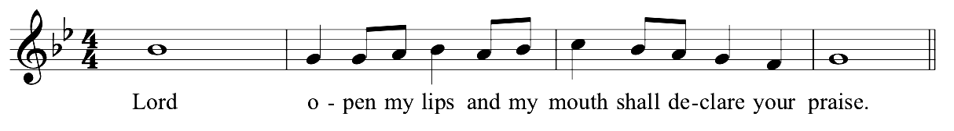
repeat after cantor and then following each verse.

The heavens declare the glory of God,
and the firmament shows for the work of his hands:
day unto day takes up the story,
and night unto night makes known the message.

Response

No speech, no word, no voice is heard,
yet their span goes forth through all the earth:
their words to the utmost bounds of the world.

Response

There he has placed a tent for the sun;
it comes forth like a bridegroom coming from his tent:
rejoices like a champion to run its course.

Response

At the end of the sky is the rising of the sun,
to the furthest end of the sky is its course:
there is nothing concealed from its burning heat.

27/9: Psalm 134
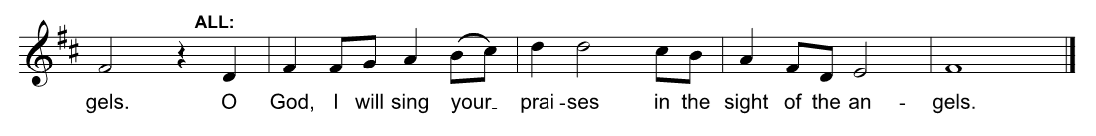

Response: O God, I will sing your praises in the sight of angels.
repeat after cantor and then after each verse.

Come bless the Lord all you servants of the Lord:
you who by night stand in the house of our God.

Response

Lift up your hands to the holy place and bless the Lord:
may the Lord bless you from Zion, the Lord who made heaven and earth.

Response

Glory to the Father and to the Son and to the Holy Spirit:
As it was in the beginning is now and ever shall be, world without end. Amen.

Response

Second Reading
Please see Pewslip for the text of the reading.
At the end of the reading:
This is the word of the Lord.
All Thanks be to God.
The Gospel

Please stand as able. The Choir and Congregation sing the Gospel acclamation.

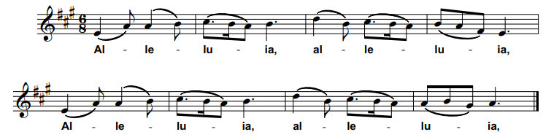
Alleluia, alleluia, alleluia, alleluia
All Alleluia, alleluia, alleluia, alleluia

God has spoken to us through his Son,
through whom he created the worlds.
All Alleluia, alleluia, alleluia, alleluia

Hear the Gospel of our Lord Jesus Christ according to N.
All Glory to you, O Lord.

At the end of the Gospel reading:

This is the Gospel of the Lord.
All Praise to you, O Christ.
Sermon

Creed
Let us declare our faith in God.

With the whole Church
All we affirm that we are made in God’s image,
befriended by Christ
empowered by the Spirit.

With people everywhere
All we affirm God’s goodness at the heart of humanity,
planted more deeply than all that is wrong.

With all Creation
All we celebrate the miracle and wonder of life,
with unfolding purposes of God,
forever at work in ourselves and the world.

Prayers of Intercession
The prayers may end with:

Merciful Father,
All Accept these prayers for the sake of your Son
our saviour Jesus Christ.
Amen.
The Liturgy of the Sacrament
The Peace
We stand.

You shall go out in joy, and be led back in peace;
the mountains and the hills before you shall burst into song,
and all the trees of the field shall clap their hands.

The peace of the Lord be always with you.
All And also with you.

Offertory Hymn
13/9: No. 169 ‘For the fruits of his creation’
27/9: No. 281 ‘How shall I sing that majesty’ (descant v.3)

Prayer at the Preparation of the Table

The table is prepared and bread and wine are placed upon it.
The president takes the bread and wine.

Blessed are you, Lord God of all creation;
you bring forth bread from the earth.
All Blessed be God for ever.

Blessed are you, Lord God of all creation;
you create the fruits of the vine.
All Blessed be God for ever.

The Eucharistic Prayer
We remain standing, as able.
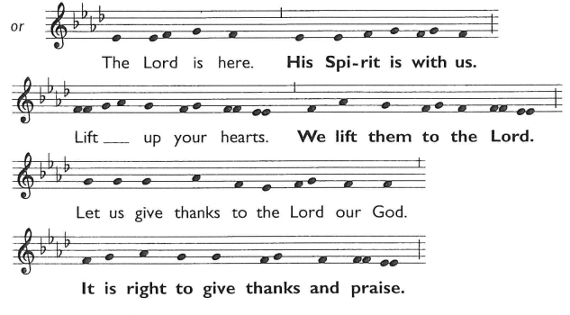
The Lord is here.
All His Spirit is with us.
Lift up your hearts.
All We lift them to the Lord.

Let us give thanks to the Lord our God.
All It is right to give thanks and praise.

Lord of all life, you created the universe,
where all living things reflect your glory.
You gave us this great and beautiful earth,
to discover and to cherish.

You hold the world in your hands,
the hills and valleys, the rivers and oceans.
You give life to every creature, plant and tree,
the seed that sleeps in the winter earth,
and awakens in the spring.
You made us all, each wonderfully different,
to join with the angels and sing your praise:

The Choir sings the Sanctus and Benedictus:
Holy, holy, holy, Lord God of hosts.
Heav’n and earth are full of Thy glory:
Glory be to Thee, O Lord most High.
Blessed is He that cometh in the Name of the Lord;
Hosanna in the highest.
We thank you loving Father,
because, when we turned away, you sent Jesus, your Son.
He gave his life for us on the cross and shows us the way to live.

Send your Holy Spirit that these gifts of bread and wine
may be for us Christ’s body and his blood.

On the night before he died, when darkness had fallen,
Jesus took bread.
He gave thanks, broke it,
and shared it with his disciples, saying:
‘This is my body, given for you.
Do this to remember me.’

After they had eaten, he took the cup of wine,
gave thanks, and shared it with his disciples, saying:
‘This is my blood poured out for you and for many,
for the forgiveness of sins.’

So, Father, with this bread and this cup
we celebrate his love, his death, his risen life.
As you feed us with these gifts, send your Holy Spirit,
and change us more and more to be like Jesus our Saviour.

Help us, Father, to love one another,
As we look forward to that day
when suffering is ended,
and all creation is gathered in your loving arms.

And now with Alphege and all your saints
we give glory, through Jesus Christ,
in the strength of the Spirit, today and for ever.
All Amen.

The Lord’s Prayer
Rejoicing in God’s new creation, we pray the prayer
our Saviour taught us, in the language of our hearts.

Our Father, who art in heaven…
Our Father in heaven…
我們在天上的父…
Pater noster, qui es in caelis…
हे हमारे पिता, तू जो स्वर्ग में है…
Vater unser im Himmel…
Amen.
The Breaking of Bread

The celebrant breaks the consecrated bread.

We break this bread
to share in the body of Christ.
All Though we are many, we are one body,
because we all share in one bread.
The Invitation
Jesus is the Lamb of God
who takes away the sin of the world.
Blessed are those who are called to his supper.
All Lord, I am not worthy to receive you,
but only say the word, and I shall be healed.

We are all invited to draw near to God today. If you, or your children, regularly receive the bread and wine at any Christian church, you are most welcome to do so. If you do not usually receive the bread and wine, or prefer not to do so today, you are invited to come forward to receive a prayer of blessing. If you do this, you may want to hold your hands together in prayer so that we know your intention. Thank you.
The Giving of Communion

Whilst those helping with the administration receive, the Choir sings the Agnus Dei.

O Lamb of God that takest away the sins of the world,
have mercy upon us.
O Lamb of God that takest away the sins of the world,
have mercy upon us.
O Lamb of God that takest away the sins of the world,
grant us Thy peace.

The Choir sings an anthem during the Distribution.

Communion Hymn
13/9: No. 167 ‘For the beauty of the earth’
27/9: No. 150 ‘Father, we love you’

The choir receives whilst all sing (remaining seated)

Post-Communion Prayer

The president prays the Post Communion Prayer from the Pewslip.

All Lord of all creation,
as we have received the bread and wine,
fruits of the earth and tokens of salvation,
so with joy we celebrate your goodness
and commit ourselves to serve you on your earth,
through Jesus Christ our Lord. Amen.
Dismissal
Notices

Blessing of Harvest Gifts
On the 13th September the harvest gifts will be blessed. This includes the produce destined for Helping Hands Foodbank and financial gifts for Water Aid.

Final Hymn
13/9: No. 705 ‘We plough the fields and scatter’
27/9: No. 51 ‘O praise ye the Lord!’

Blessing
May God, the Father of our Lord Jesus Christ,
the source of all goodness and growth,
pour his blessing upon all things created,
and upon you his children,
that you may use his gifts to his glory
and the welfare of all peoples;
and the blessing of God almighty,
✚ the Father, the Son, and the Holy Spirit,
be among you and remain with you always.
All Amen.

Tend the earth, care for God’s good creation,
and bring forth the fruits of righteousness.
Go in peace to love and serve the Lord
All In the name of Christ. Amen.

Organ Voluntary
Please see Pewslip for details.

Growing Disciples, Building Community, Transforming Lives
www.solihullparish.org.uk
linktr.ee/solihullparish

